SALE LOCATION: CONTRACT PERIOD: Project Completion by November 1, 2018
Juneau County, Township of Clearfield CONTACTS:
Section: 12 Town: 17N Range: 03E DNR Forester, Sarah Gollnick (608) 847-9394
Sale Size: 21 Acres District Superintendant, Tanya Kotlowski (608) 565-2256 ext.120

THIS IS A SCALED SALE (MILL SCALE ACCEPTABLE).

PRODUCT LISTING:
Species: | Estimated Pulpwood Tons: | Notes:
Red Pine | 210
White Pine | 55

SALE OBJECTIVE: Thin the existing pine stand to maintain health and vigor of remaining stand.
CUTTING AREA DESCRIPTION: This tract is located on the West side of State Highway 58, between Necedah and Mauston. The sale boundary is not marked. All Red and White Pine marked with orange paint are to be cut. The tract consists of 1 cutting unit totaling 21 acres.

CUTTING REQUIREMENTS/ SPECIFICATIONS:
- Cut and utilize all trees marked with orange paint.
- This sale requires the purchaser to complete Annosum root rot preventative treatment if harvested April 1 to November 30. Treatment must be performed by a Certified Pesticide Applicator. Treatment involves treating all fresh cut stumps of pines of merchantable size by applying either CELLU-TREAT (disodium octaborate tetrahydrate) or Rotsop C (Phlebiopsi gigantea). Treatment shall be made the same day as harvest and a dye product shall be added to liquid solutions for inspection purposes. The cost of this application can vary based on application method and harvest conditions, but should be considered when submitting bids.

ACCESS: Access to the sale is directly from State Highway 58.

OTHER SALE REQUIREMENTS AND CONDITIONS:
- The successful bidder will be required to sign a contract and provide a performance bond in the amount of 10% of the estimated sale value. A copy of the contract may be obtained from the district office.
- Weight/ Volume conversion factors (if needed) will be listed as Option 2 on page 12-1 of the Wisconsin Timber Sale Handbook. Copies are available upon request.
- Notify the DNR forester or District Superintendent before you start job.
- Check contract for other requirements.

Timber Sale Map Juneau County, Township of Clearfield
Section: 12 Town: 17N Range: 03E
N

Scale 12” = 1 mile

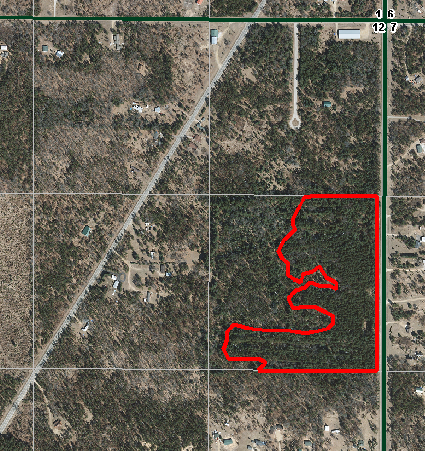
Sale Area
State Highway 80
State Highway 58

